MGFC Club Calendar for 2016-2017 financial year
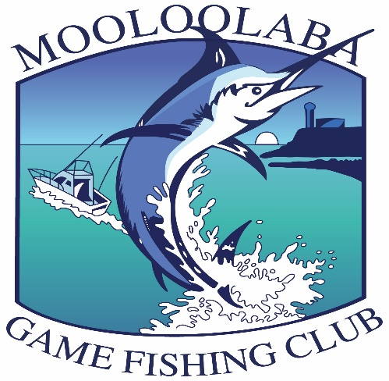

October
1st & 2nd Rally day weekend/ Social BYO BBQ
5th General meeting/tackle night TYC (Wednesday)
10th Committee meeting (Monday)
28th all tag cards from previous month due in

November
4th & 5th Rally day weekend/Social BYO BBQ
Saturday 12th Christmas Party Barra Park, Bli Bli
14th Committee meeting (Monday)
Friday 25th, Saturday 26th, & Sunday 27th Billfish Bash Tournament
28th all tag cards from previous month due in

December
3rd & 4th Rally day weekend
7th General meeting/Tackle night BCF Maroochydore (Wednesday)
12th Committee meeting (Monday)
28th all tag cards from previous month due in

January
7th & 8th Rally day weekend/Social BYO BBQ
9th Committee meeting (Monday)
28th all tag cards from previous month due in
February
1st General meeting TYC (Wednesday)
4th & 5th Rally day weekend/Social BYO BBQ
Friday 10th & Saturday 11th Billfish Babes one day shoot out
13th Committee meeting (Monday)
Friday 24th & Saturday 25th Billfish Babes tournament back –up dates
28th all tag cards from previous month due in

March
4th & 5th Rally day weekend/ Flathead classic - BBQ
13th Committee meeting (Monday)
28th all tag cards from previous month due in

April
1st & 2nd Rally day weekend/Social BYO BBQ
5th General meeting watch this space (Wednesday)
10th Committee meeting (Monday)
Friday 21st, Saturday 22nd & Sunday 23rd the 25th Billfish Bonanza Tournament
28th all tag cards from previous month due in

May
6th & 7th Rally day weekend/ Social BYO BBQ
8th Committee meeting (Monday)
28th all tag cards from previous month due in

June
3rd & 4th Rally day weekend/Social BYO BBQ
7th General meeting TYC (Wednesday)
12th Committee meeting (Monday)
9th, 10th & 11th Social camping weekend
28th all tag cards from previous month due in

July
1st & 2nd Rally day weekend/Social BYO BBQ
10th Committee meeting (Monday)
28th all tag cards due in from previous month
Sunday 30th Junior tournament – Reelax in the river

August
5th & 6th Rally day weekend/Social BYO BBQ
11th, 12th & 13th QGFA AGM Mackay
Saturday 19th MGFC AGM & Presentation dinner

Christmas Party
Light and Heavy Tackle Tournaments
Billfish Babes tournament
Junior Tournament
AGM and Presentation
Social events ( Flathead classic, camping weekend)

